“파라과이여, 다시 태어나라”(Paraguay must be born again)(요3:7)
Esperanza del Paraguay(“파라과이의 희망”)
파라과이 선교 계획 표어
“한 알의 밀이 땅에 떨어져 죽지 아니하면 한 알 그대로 있거니와 죽으면 많은 열매를 맺느니라”(요12:24)
3차 5개년 계획의 7대 목표: 제사장, 예배자, 제자, 중보자, 봉사자, 전도자, 행동하는 사람
2026년 표어: “복음을 전파하라”
(Vayan por todo el mundo y anuncien las buenas noticias a toda criatura)

Dear Officers and Supporters of JSBMF
Hallelujah! Greetings to the JSBMF families in the name of Jesus Christ In the name of our Lord Jesus Christ, I send my greetings to our mission partner in Paraguay.
After sharing the mission news with each individual and the church, I would like to present a message on behalf of the organization this time.
Now that the sweltering summer has passed, you can probably hear the sounds of fall approaching, can’t you? Of course, spring has just begun here in Paraguay. A topic and term that frequently appear on YouTube these days is “reverse migration.”

I hear there are many people who, after living in the United States for a long time, miss their homeland and have decided to return to their native country. It makes me wonder just how much they must miss their homeland to choose to “re-emigrate” back to their native country, leaving behind a lifetime spent as immigrants. It seems to be human nature for people to flock home during holidays (this week is Chuseok in Korea). I’ve also been hearing that many Korean expatriates who immigrated to Paraguay have returned to their homeland.

Abraham, the first immigrant, must have longed to return to his homeland as well. Yet, even though he had the opportunity to return, he chose to live as a foreigner and a stranger, looking forward to the eternal homeland and the city God had prepared for him. I want to follow his example. (Hebrews 11:13–17)
★ Greetings for the Chuseok holiday.

★ Starting the construction of the student dormitory building again 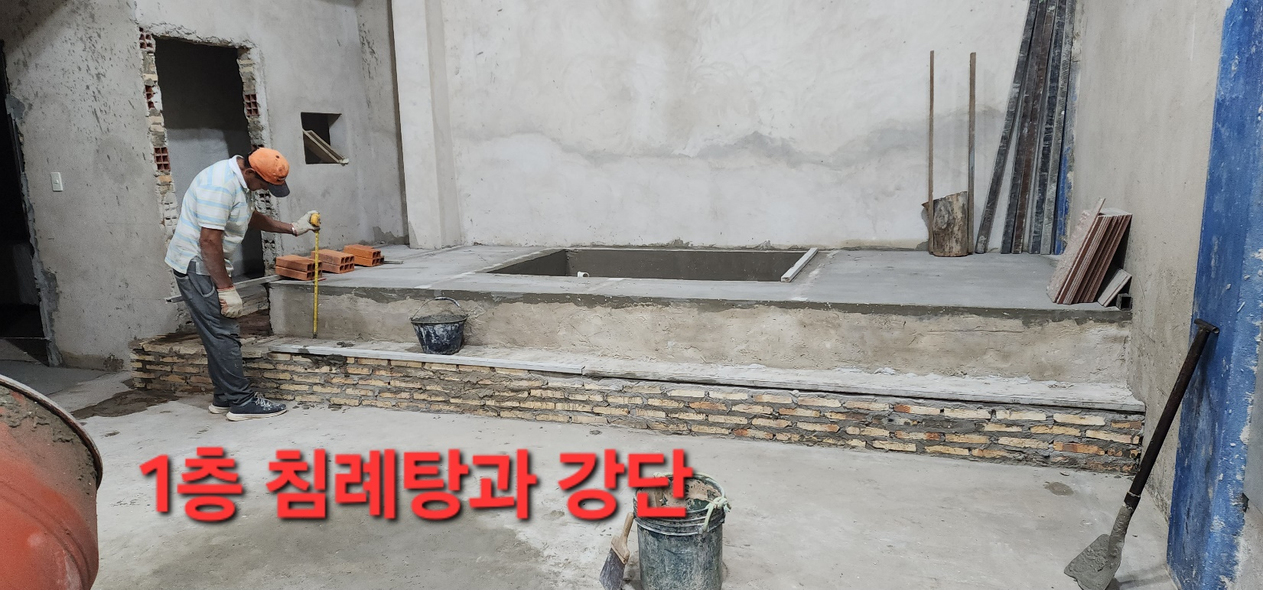
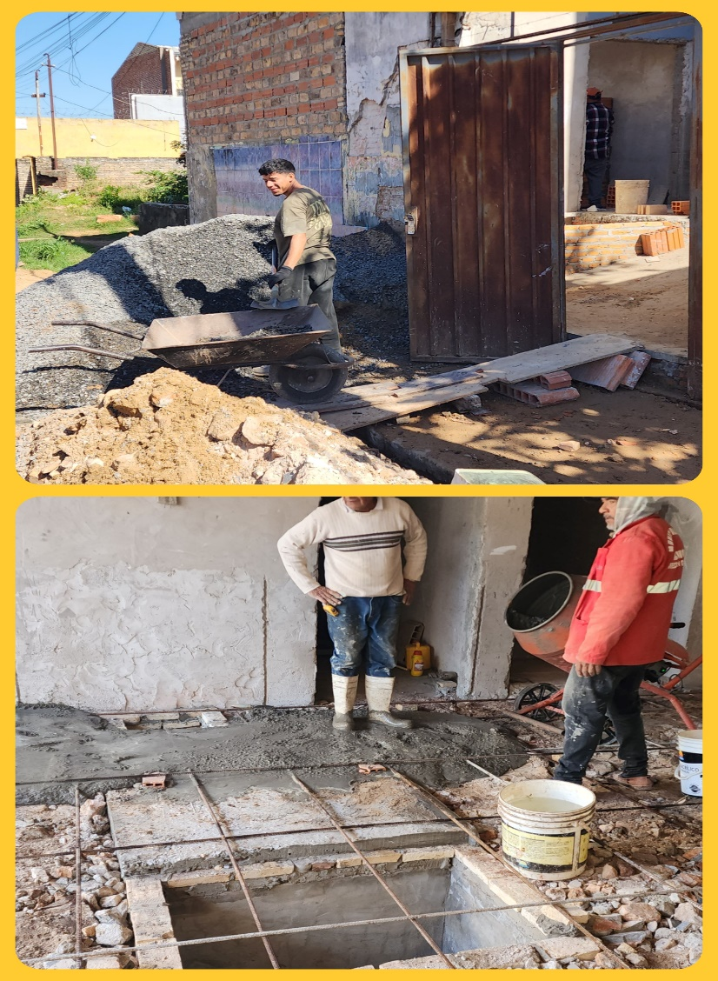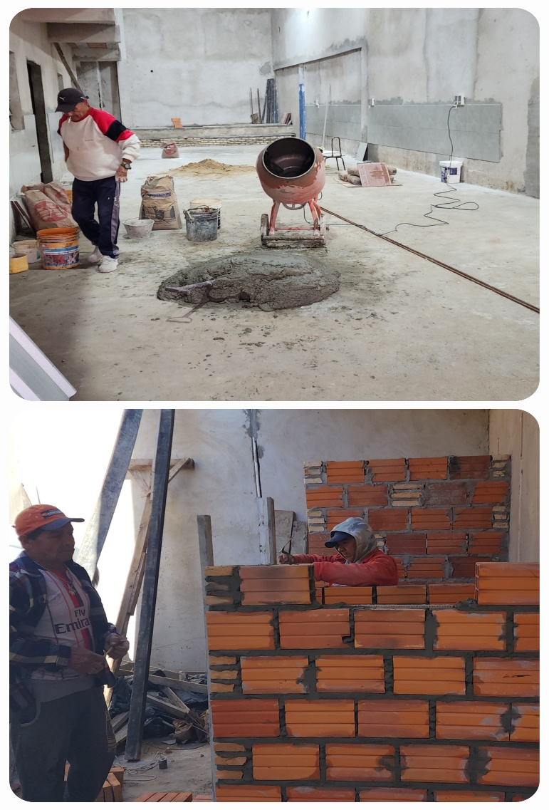
샤워장 공사
정화조 완성
We were unable to complete the construction of the dormitory for over a year and had to suspend work on July 10. Living in an environment where I could think of nothing but the construction wore me down both physically and mentally. I experienced many nights where I would wake up in the middle of the night thinking about the construction and then be unable to fall back asleep, which made me realize that construction is by no means an easy task.
However, since I felt I had to finish what I had started, I set a schedule of two to three months beginning September 1 and resumed work. I reflect on the work God will accomplish through the construction of the dormitory. I imagine hundreds of children singing praises, listening to the Word, and playing together. I also think about how beautiful it will be to see teenage students living in the dormitory and receiving training there. Isn’t it a glorious sight to see children who have been trained from a young age grow up to become warriors of Christ, used by God?
Although it will be difficult until the construction is complete, just as Abraham lived by faith in a foreign land, looking forward to a better homeland for God’s glory, I press on, looking only to the city that God has planned and will build.
I am grateful that you not only pray for us constantly but also continue to support our mission work, even though the church is not well-off and the congregation is not wealthy. I also sincerely thank you for sending funds for the dormitory construction and scholarships, which have given us strength and courage. I pray that God’s blessings and grace may abound in JSBMF and in each of your households. Shalom.
Your Missionaries in Paraguay, Ok Jin & David Nam

★ Prayer Topics for the 3rd 5-Year Plan for the Paraguay Mission
(September 2023 - August 2028)
1. So that missionaries who will work together can come to Paraguay.
2. For the construction of the Academic Building.
3. For the evangelization of the entire village of , the slum where the church is located
4. 350 <Warriors of Christ> Goal
5. May the salvation of souls be abundant through the Church of Hope.
6. Please fill me with the Holy Spirit and let me live according to God’s will.
“Paraguay, Born Again!”
My Lord, my God. Please receive us and lead us! Amen.

