“파라과이여, 다시 태어나라”(Paraguay must be born again)(요3:7)
Esperanza del Paraguay(“파라과이의 희망”)
파라과이 선교 계획 표어
“한 알의 밀이 땅에 떨어져 죽지 아니하면 한 알 그대로 있거니와 죽으면 많은 열매를 맺느니라”(요12:24)
3차 5개년 계획의 7대 목표: 제사장, 예배자, 제자, 중보자, 봉사자, 전도자, 행동하는 사람
2026년 표어: “복음을 전파하라”
(Vayan por todo el mundo y anuncien las buenas noticias a toda criatura)

Dear Officers and Supporters of JSBMF
Hallelujah!
Greetings to the JSBMF family in the name of Jesus Christ I believe that all members of the JSBMF family will look to the Lord even more and live in joy and peace. As the United States leaves behind the fresh scent of spring and heads toward the hot summer, I am praying that the JSBMF family will always be filled with grace and love.
★ We spent the day celebrating Mother's Day and Father's Day.
Here, Mother's Day is on May 15th, and Father's Day falls on the third Sunday of June, just like in the United States.
On Mother's Day, we prepared gifts, and the church leaders sang the song "Mother's Grace" in Korean to honor the mothers. For Father's Day, we took the fathers out together (three of them) to treat them to lunch.
. 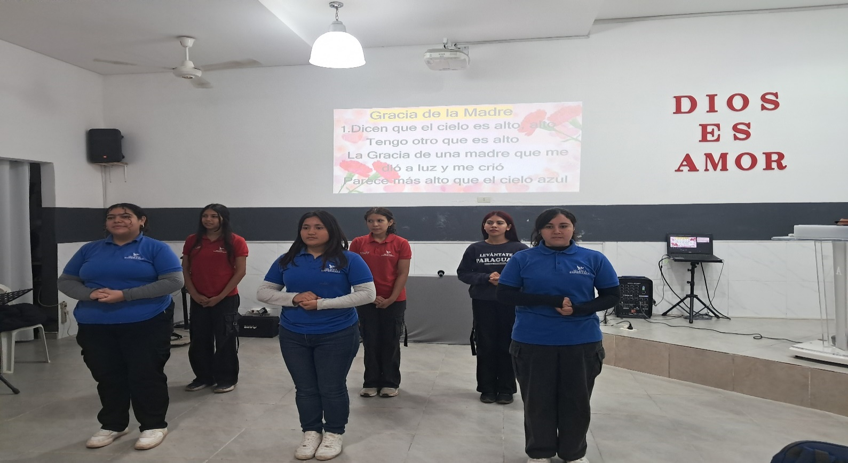
In every family, fathers must live by faith for the family to be transformed into something beautiful, but this is not the case in Paraguay.
It would be wonderful if mothers could “teach their children the way they should go” through their faith, but I find myself beating my chest in prayer as I see them living lives consumed solely by their own interests and lusts.
“May parents be transformed so that families may stand firm in the Lord.”
This is not a prayer offered only during May, the Month of the Family, but a prayer that is desperately needed in the mission field.
★ The first year (week 52) of dormitory construction…
정화조
(Septic Tank)

It’s already been a year since construction began on the dormitory. I thought it would be completed in six to seven months, but the project has dragged on so long that I’m growing weary both physically and mentally.

We have now paid the architect all the necessary construction fees, but the fact that the work is still not finished and requires additional expenses weighs heavily on my mind. There are times when I lose sleep and stay awake all night. Even though I watch over the construction site every day, the workers are slow, and on some days they skip work... I find myself wondering, "Is construction really a job that requires a pastor to grind wear his body out?” Having devoted myself to this construction project for a year, I’m dismayed to see that my ministry—including caring for the children—has been reduced to a bare minimum. During early morning prayer, I beat my chest and plead, “Please, just preserve their lives!!!”
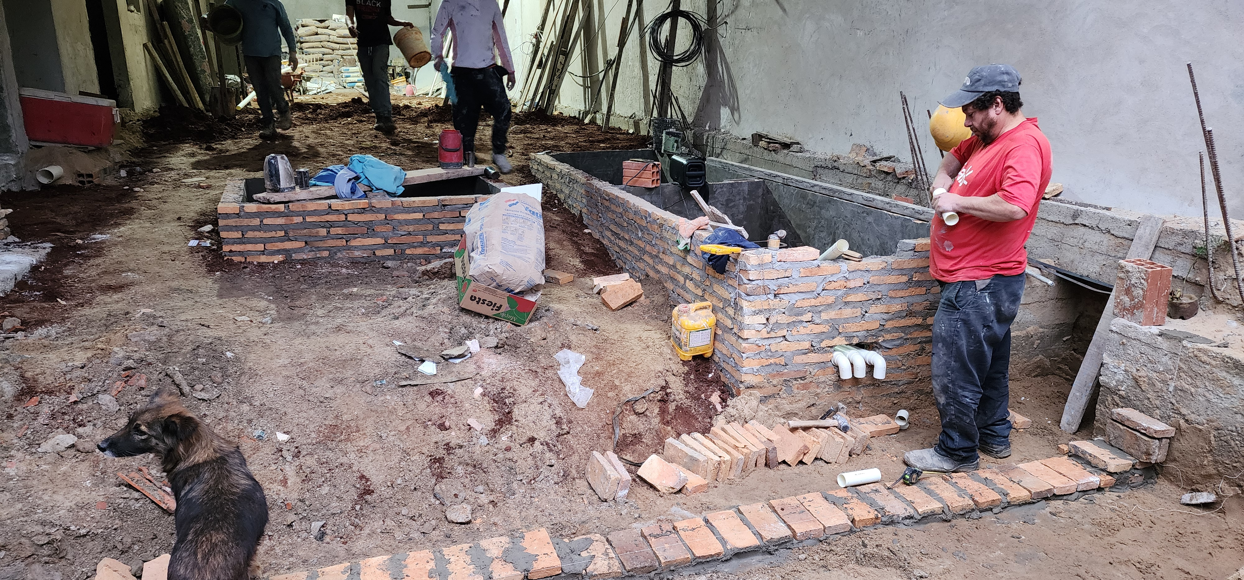

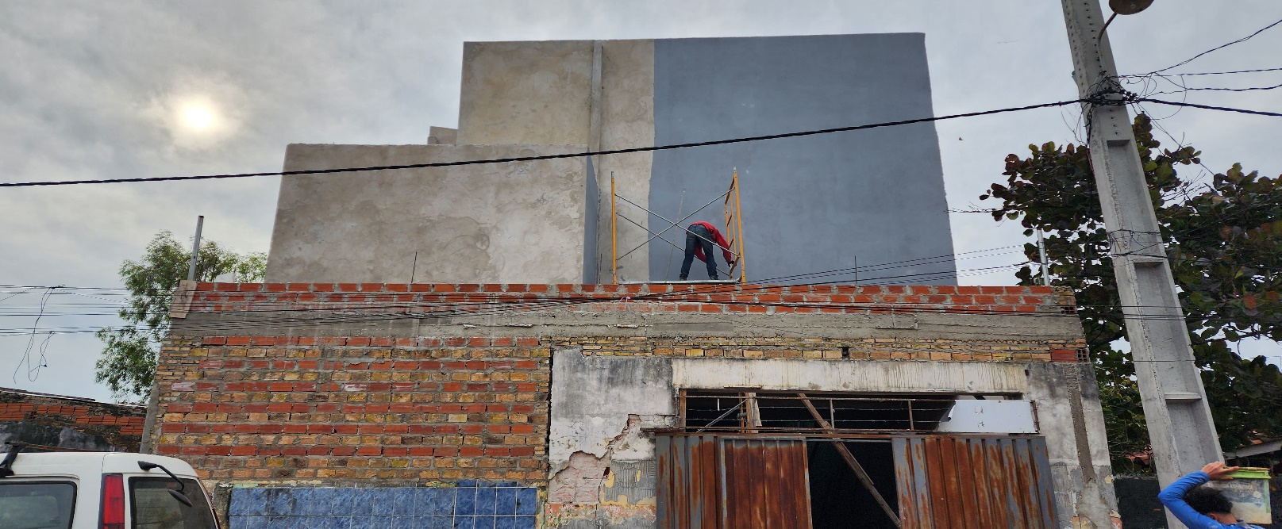
외벽 페인트 작업

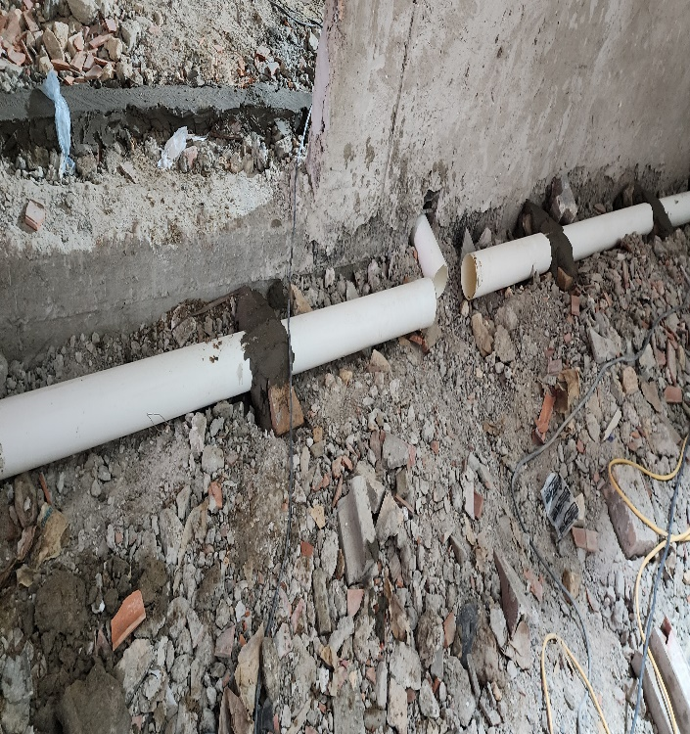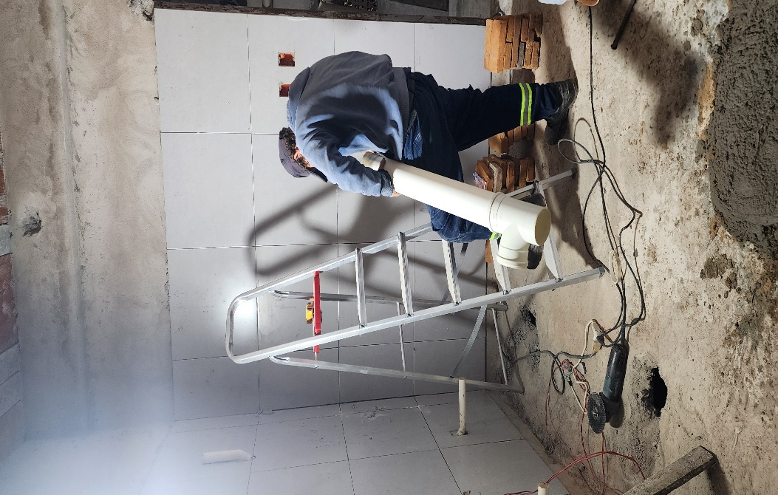
수도와 하수관 설치 작업

I believe that when reporting on missionary work, I should always present a positive, bright, and progressive image, but I apologize for showing a struggling side in this report. Lately, the scripture I have been meditating on is Psalm 23. “Even though I walk through the valleys of the shadow of death, I shall fear no evil, for You are with me; Your rod and Your staff comfort me.” Although I sometimes spend sleepless nights over a single construction project, I wonder how King David endured all kinds of hardships to survive? Ostracism by brothers, the death of a son, violence from his own children, a son’s rebellion in his old age and the death of that son…
How could I ever dare to compare myself to David? Nevertheless, I meditate on David’s faith, as he lived his life confessing, ♪What other worries could I have while I am in You? I went to the foot of the cross and laid down my burdens~~~♬ ♬That fear turned into my prayer, and the sighs of yesterday turned into my song~~~♬ I come forward, praising the Lord and crying out to Him. I believe You are praying with me.
From July 14 to 24, the Overseas Mission Committee (chaired by Rev. Joseph Cho) and the Pittsburgh Korean Church are visiting Paraguay to prepare for a youth retreat and a pastors’ seminar.
We pray that through this pastors’ seminar, pastors in Paraguay will be transformed to serve with their eyes fixed entirely on the Lord.

I sincerely thank all the JSBMF family members who are partnering with us. I pray that joy and peace in the Lord will fill every family member. Shalom
Your Missionaries in Paraguay Ok Jin & David Nam

★ Prayer Topics for the 3rd 5-Year Plan for the Paraguay Mission
(September 2023 - August 2028)
1. So that missionaries who will work together can come to Paraguay.
2. For the construction of the Academic Building.
3. For the evangelization of the entire village of , the slum where the church is located
4. 350 <Warriors of Christ> Goal
5. May the salvation of souls be abundant through the Church of Hope.
6. Please fill me with the Holy Spirit and let me live according to God’s will.
“Paraguay, Born Again!”
My Lord, my God. Please receive us and lead us! Amen.

