“파라과이여, 다시 태어나라”(Paraguay must be born again)(요3:7)
Esperanza del Paraguay(“파라과이의 희망”)
파라과이 선교 계획 표어
“한 알의 밀이 땅에 떨어져 죽지 아니하면 한 알 그대로 있거니와 죽으면 많은 열매를 맺느니라”(요12:24)
3차 5개년 계획의 7대 목표: 제사장, 예배자, 제자, 중보자, 봉사자, 전도자, 행동하는 사람
2025년 표어: 천국을 바라보자(Hacia al Cielo)
Dear Officers and Supporters of JSBMF
Hallelujah!
Greetings to the JSBMF family in the name of Jesus Christ I believe you have celebrated Thanksgiving Day in the Lord's grace. It seems like only yesterday that 2025 began, yet already, with Thanksgiving past, the time to reflect on the year is approaching.
I meditate on the heart of Moses, who prayed, "Teach us to number our days, that we may gain a heart of wisdom" (Psalm 90:12). Just as Moses, who lived to the ripe old age of 120, lived each day looking upward, counting the days, I too desire to live my life cherishing my time and looking to the Lord who saved me from death.

★ Pastor Kim Joo-young (Church 153) visits Paraguay
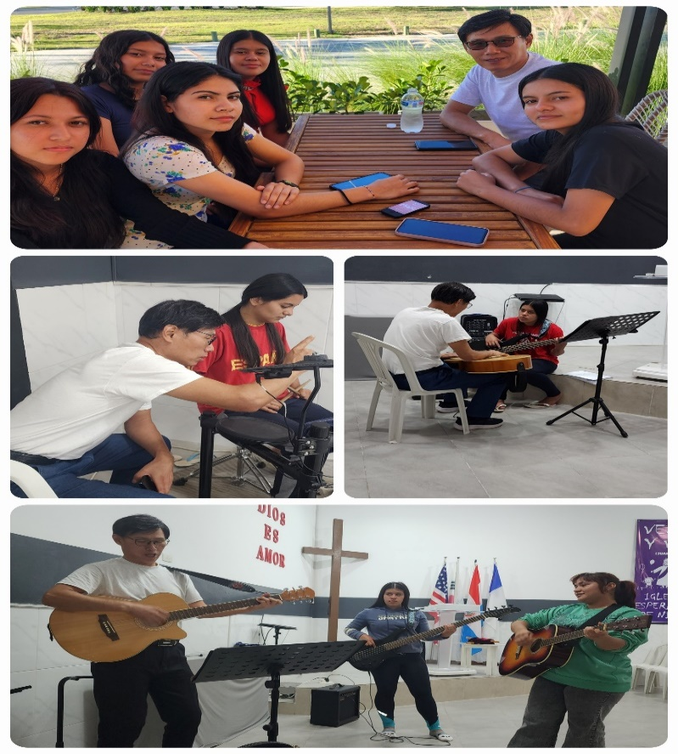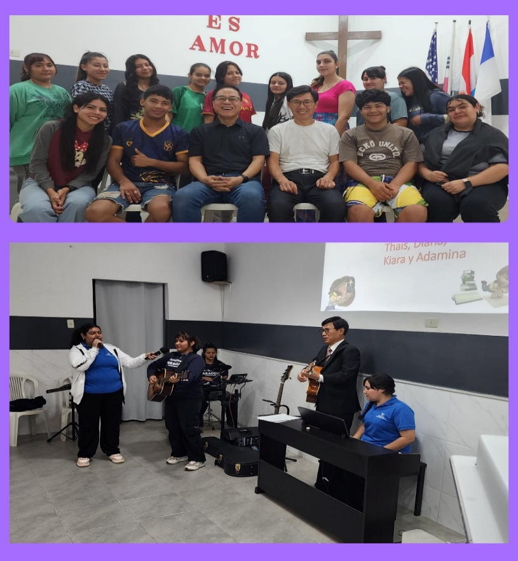
Pastor Kim Joo-young, who serves at 153Church in Atlanta, visited for two weeks to advise on the construction of the dormitory and to further teach the students guitar and drums. This was his third visit, and he had previously taught the children instruments, allowing them to play the drums and guitar. This time, he provided meticulous instruction to help the children improve their skills. I am truly grateful for his heart for the Paraguay mission field.
★ Completed the 23rd week of building construction
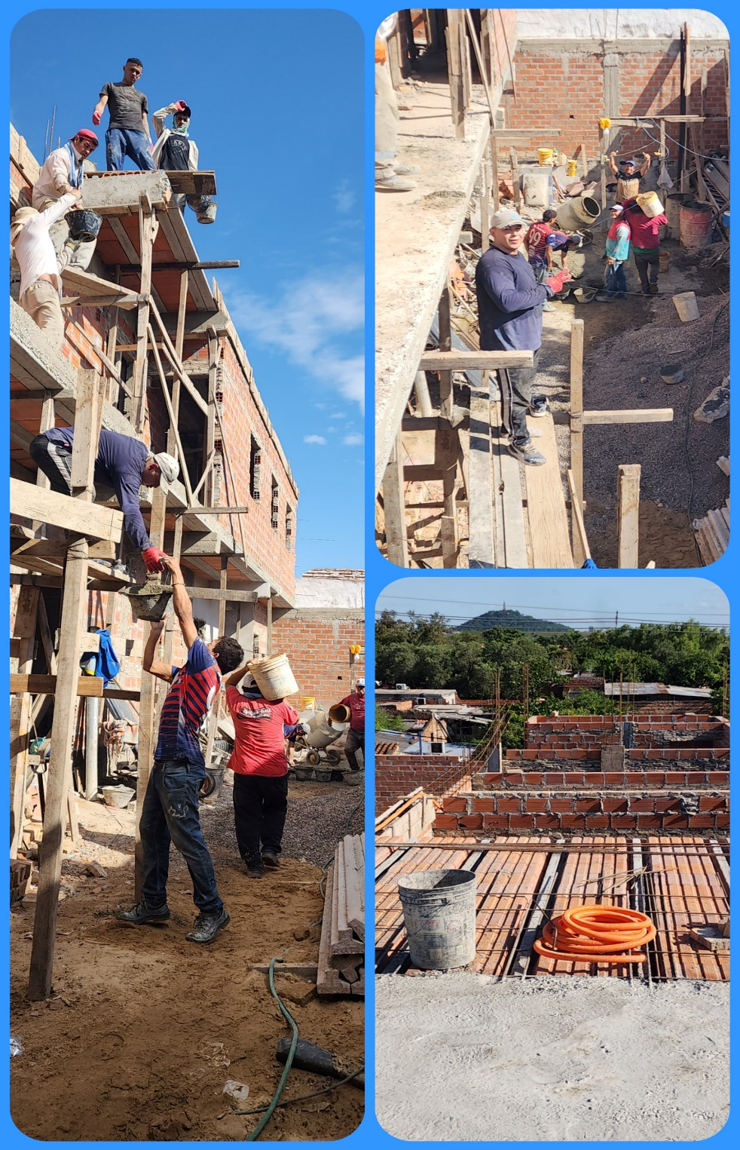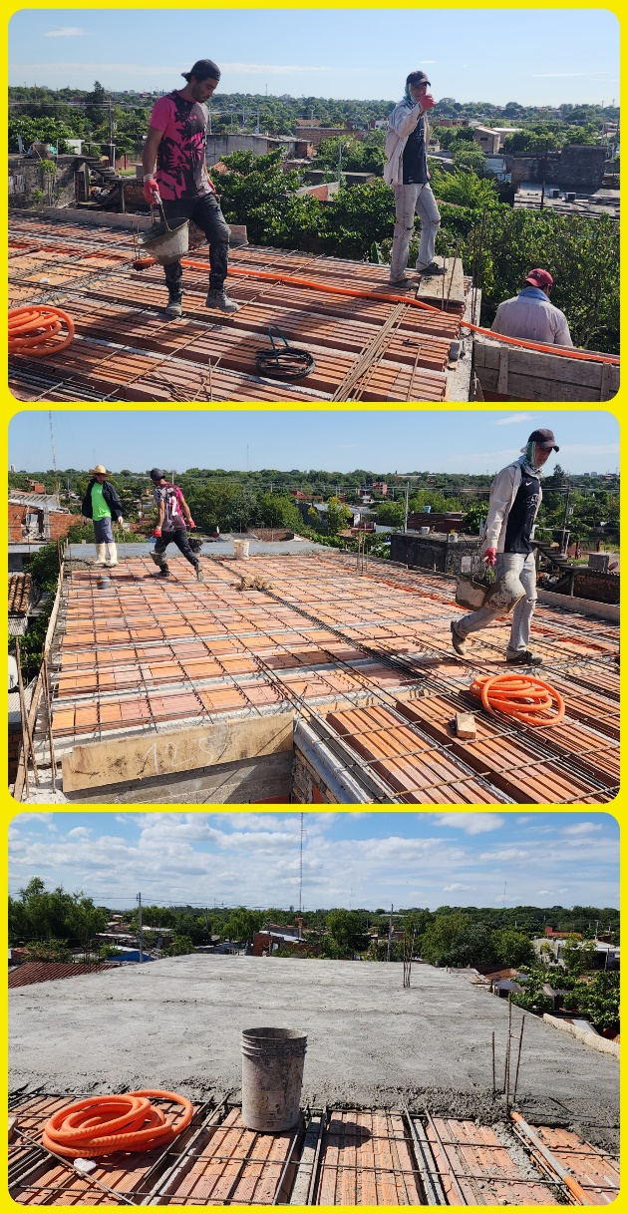
It has been five months since construction began on the dormitory. While we anticipated delays in the workers' progress here, it has become excessively slow. Given that all construction tasks are being done manually without equipment, it seems inevitable that delays would occur. We believe God's guidance is at work even in these delays and wait patiently.
They are currently pouring the second-floor slab. As the building stands about 10 meters tall, I pray for the workers' safety during construction. I am grateful for your prayers and ask for your continued support until completion. The architect says it should be finished by mid-February next year, but I'm praying for a safe and robust construction.

I confess that it was by God's grace that I was able to carry out the mission in Paraguay to this day. Furthermore, the Holy Spirit, through His guidance and prayerful support, brought us together with JSBMF. Everything was possible because of God's grace.
"Give thanks to the Lord, for He is good; His love endures forever." "Give thanks to the God of heaven, for His love endures forever." (Psalm 136:1, 26)
I pray that the grace and blessings of our Lord Jesus Christ will overflow on Thanksgiving Day, and I thank you for your love and partnership with JSBMF Families. Shalom

Your Missionaries in Paraguay
Ok Jin & David Nam

★ Prayer Topics for the 3rd 5-Year Plan for the Paraguay Mission
(September 2023 - August 2028)
1. So that missionaries who will work together can come to Paraguay.
2. For the construction of the Academic Building.
3. For the evangelization of the entire village of , the slum where the church is located
4. 350 <Warriors of Christ> Goal
5. May the salvation of souls be abundant through the Church of Hope.
6. Please fill me with the Holy Spirit and let me live according to God’s will.
“Paraguay, Born Again!”
My Lord, my God. Please receive us and lead us! Amen.
<Contact Information>
● US Mailing address (미국 연락처) : Attn: Joseph Nam(469-964-6173)
All Nations
1516 Lakeway Drive • Little Elm, TX 75068
● Bank of America (Pay to the Order: All Nations Church of Dallas)
Routing #: 111000025 Account #: 488028516745
● e-mail : davidnam1128@gmail.com
● Paraguay Address (파라과이 연락처)
Tacuari y entre 38 y 39 proyectada • Asuncion, Paraguay +595 994-796900(cell phone)
● 한국: NAM DAVID HAK(국민은행) 054901-04-203605

