“파라과이여, 다시 태어나라”(Paraguay must be born again)(요3:7)
Esperanza del Paraguay(“파라과이의 희망”)
파라과이 선교 계획 표어
“한 알의 밀이 땅에 떨어져 죽지 아니하면 한 알 그대로 있거니와 죽으면 많은 열매를 맺느니라”(요12:24)
3차 5개년 계획의 7대 목표: 제사장, 예배자, 제자, 중보자, 봉사자, 전도자, 행동하는 사람
2025년 표어: 천국을 바라보자(Hacia al Cielo)
Dear Officers and Supporters of JSBMF
Hallelujah!
Greetings to the JSBMF family in the name of Jesus Christ.
It has already been more than a month since I attended the General Assembly in May.
After returning from the General Assembly, I was so busy with the construction of the dormitory that I skipped the mission report that I should have sent in May for the first time.

We are constantly being bombarded with news of war. The war in Russia and Ukraine seems to have no end in sight, along with the warlike conflicts in India and Pakistan, and now Israel's war with Iran, the arch enemy of Shiite Islam, is breaking our hearts.
It breaks our hearts to think of people dying in these wars, even if they are end times prophecies that Jesus already spoke of and are familiar to the saints.

Jesus, who chose his disciples, said to them as he sent them out into the world, “So do not fear them. For there is nothing covered that will not be revealed, or hidden that will not be known.”(Matthew 10:26) The deeds of men will be revealed, both good and bad; they will come to us in sheep's clothing, but inwardly they are ravenous wolves; they are coming to us with sharp teeth hidden behind smiles for their own power and profit. Nevertheless, we go forward in faith for the mission entrusted to us.

★ Mother's Day Thanksgiving Service
Although it is a Mother's Day service held every year, we shared groceries with mothers to bring joy to their hearts for even just one day, and invited those over 60 years old to Burger King for lunch. Since it is a church centered on children, we cannot pay special attention to adults, but they are still precious to us because they come regularly.
In particular, the praise team sang <Mother's Grace> in Korean, translated it, and showed it as a video as a special performance. The praise team practiced for several weeks and memorized the Korean and sang it, and they did well.
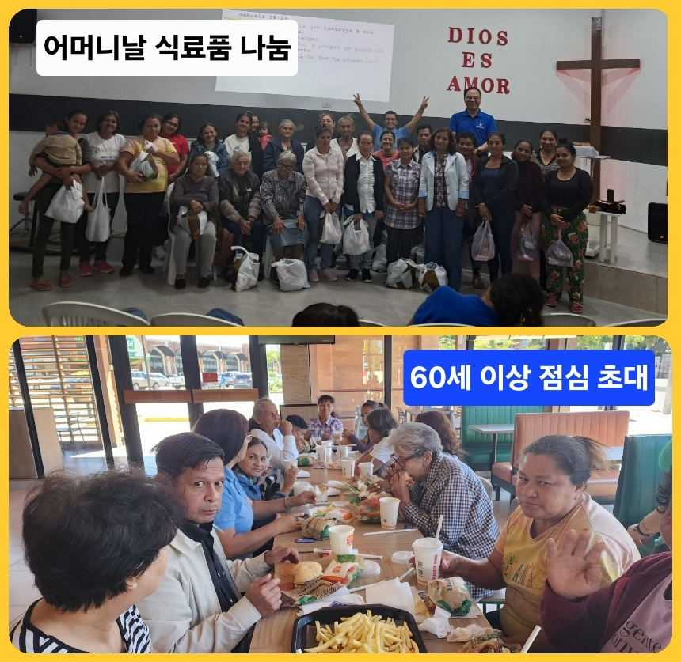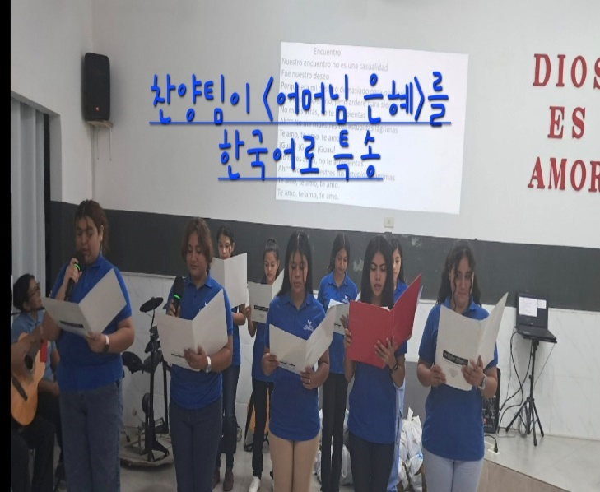
★ the construction of the DORMITORY FOR STUDENTS Building Started
The construction that we have been preparing and praying for finally started on June 17th. Hallelujah!!!
The most important ministry in the 3rd Five-Year Plan is the Dormitory Building construction. The most difficult and challenging work in the slums is changing the lives of children. It is not easy to change the habits and behaviors that we learn from our parents from a young age. The fact is that once those habits have become our own opinions and become ideologies, it is very difficult to change them into people of God. Therefore, the <Dormitory Construction> plan is to have children who have been living a life of faith together since childhood share a life of community together after they turn 18.
<The dormitory for students> is a place where young people who are entering university or receiving job training live together. Everything is free here, and they eat together and receive discipleship and faith training, life training, and job training.
It's a hopeless life where a student can't hope to do well in school when they don't even have a desk to study at, and college is out of the question when they don't have money. They are born in the slums, fall in love here, have children in a marriage without a wedding, and then live in poverty like it's their destiny.
But even for these children, a sprout of hope began to grow. Because of Jesus, they found a <home> in the church. They had hope that they could go to college and get a good job. As they go to college and study, they also start to dream of going to a foreign university.
In the future, <The dormitory for students> > will be a school of survival and a school of dreams. It will be very difficult to run. It will be even more difficult because of the differences in habits, but when I see the children changing, I see hope.
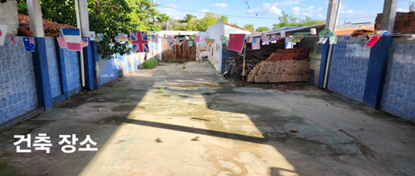
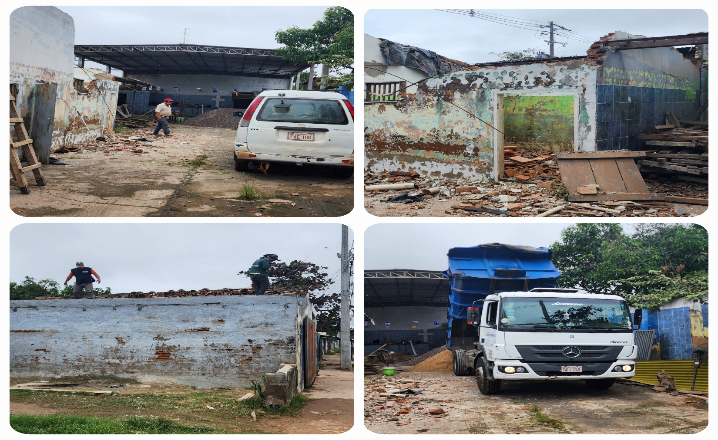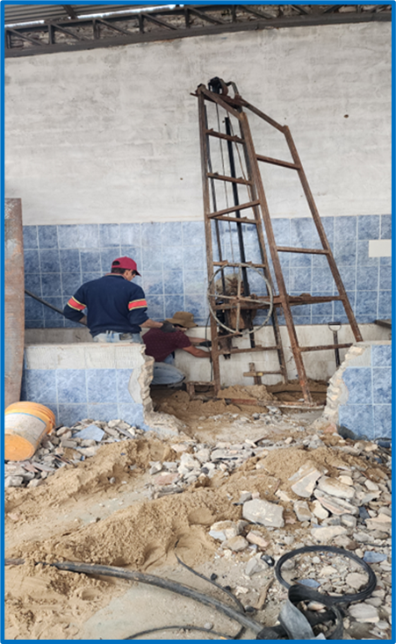
Pile 작업(25개) 시작
구건물 철거 부터 시작
<The dormitory Building> will have a Sunday school classroom, a dining hall, a library, a conference room, a job training facility, five bedrooms (for 20 people), a missionary family residence, a guest room, four bathrooms, and a small playground where many meetings will take place
We are aiming to complete it by the end of this year. It may be delayed, but we are trying to complete it by January next year. We asked a construction company, but the estimate was too high, so instead of leaving it to the company, we contracted it out to a group of workers and I will supply the building materials. The cost of building materials has increased significantly since the church was built four years ago, but we are moving forward with the belief that the Holy Spirit will finish it well since He has started the work. Please pray for us to work together.
★ We meet at church every day.
We are busy with the construction of the <Dormitory Building> and there are many things to be concerned about, but the Holy Spirit moved us to gather the children who go to school in the afternoon and evening during the construction period to pray for the construction, read the Bible, and study Korean, so we have been meeting at the church every day since last week. We have one hour of prayer, breakfast, reading 10 chapters of the Bible and teaching Korean every day. But what I am thankful for is that little by little, the children who went to school in the morning also come to the church to pray and read the Bible. They used to do it only during the vacation period. They started to have a proper training even before they moved into the bachelor house. Hallelujah!!!
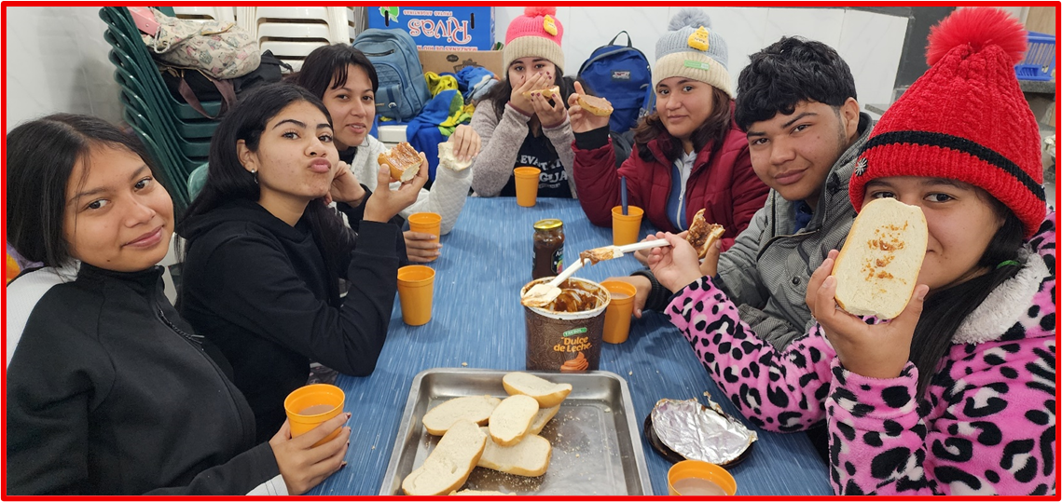
매일 아침과 오후에 모임
“Whatever you did for one of the least of these, you did for me,” Jesus taught his disciples before his crucifixion (Matthew 25:40). We are willing to serve children, even if they are smelly, unwanted children, until they consider the church their “NEST”... until we see them transformed into children who give their lives to the Lord.
My heartfelt thanks to the JSBMF family for doing mission work together. Shalom.
Your Missionaries in Paraguay
Ok Jin & David Nam

★ Prayer Topics for the 3rd 5-Year Plan for the Paraguay Mission
(September 2023 - August 2028)
1. So that missionaries who will work together can come to Paraguay.
2. For the construction of the Academic Building.
3. For the evangelization of the entire village of , the slum where the church is located
4. 350 <Warriors of Christ> Goal
5. May the salvation of souls be abundant through the Church of Hope.
6. Please fill me with the Holy Spirit and let me live according to God’s will.
“Paraguay, Born Again!”
My Lord, my God. Please receive us and lead us! Amen.

<Contact Information>
● US Mailing address (미국 연락처) : Attn: Joseph Nam(469-964-6173)
All Nations
1516 Lakeway Drive • Little Elm, TX 75068
● Bank of America (Pay to the Order: All Nations Church of Dallas)
Routing #: 111000025 Account #: 488028516745
● e-mail : davidnam1128@gmail.com
● Paraguay Address (파라과이 연락처)
Tacuari y entre 38 y 39 proyectada • Asuncion, Paraguay +595 994-796900(cell phone)
● 한국: NAM DAVID HAK(국민은행) 054901-04-203605

